1.

2.

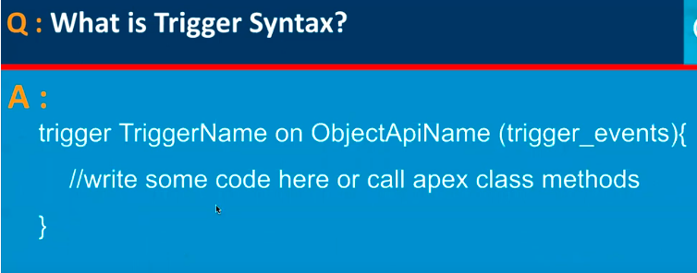

3.

4.

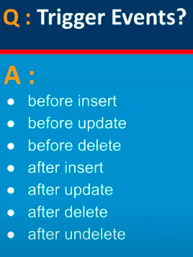

5.

6.

7.

8.

9.

10.

11.

12.

13.

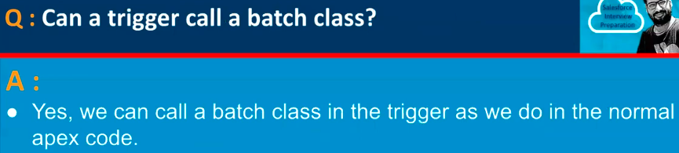

14.

15.

16.

17.

